ABSTRACT
Automatic Light Control System is a simple yet powerful concept, which uses transistor as a switch. By using this system manual works are 100% removed. It automatically switches ON lights when the sunlight goes below the visible region of our eyes. This is done by a sensor called Light Dependant Resistor (LDR) which senses the light actually like our eyes. It automatically switches OFF lights whenever the sunlight comes, visible to our eyes.
By using this system energy consumption is also reduced because nowadays the manually operated street lights are not switched off even the sunlight comes and also switched on earlier before sunset. In this project, no need of manual operation like ON time and OFF time setting.
This project clearly demonstrates the working of transistor in saturation region and cut-off region.

CHAPTER ONE

INTRODUCTION
Automatic light controllers are smarter versions of the mechanical or electronic timers used for the control of light ON-OFF operation. They come with energy conservation options like twilight saving, staggering or dimming. Also some light controllers come with an astronomical clock for a particular location or a Global Positioning System (GPS) connection to give the best ON-OFF time and energy saving. Automatic Light Control System is a simple and powerful concept, which uses transistor as a switch to switch ON and OFF the light automatically. By using this system manual works are removed. It automatically switches ON lights when the sunlight goes below the visible region of our eyes. It automatically switches OFF lights under illumination by sunlight. This is done by a sensor called Light Dependant Resistor (LDR) which senses the light actually like our eyes by using this system energy consumption is also reduced because now-a-days the manually operated lights are not switched off properly even the sunlight comes and also not switched on earlier before sunset. In sunny and rainy days, ON time and OFF time differ
significantly which is one of the major disadvantage of using timer circuits or manual.
This project exploits the working of a transistor in saturation region and cut-off region to switch
ON and switch OFF the lights at appropriate time with the help of an electromagnetically
operated switch.
A lamp standard, lamppost, street lamp, light standard, or Street light
Is a raised source of light on the edge of a road or walkway, which is turned on or lit at a certain time every night. Modern lamps may also have light-sensitive photocells to turn them ON at dusk, OFF at dawn, or activate automatically in dark weather. In older lighting this function would have been performed with the aid of a solar dial.
This project exploits the working of a transistor in saturation region and cut-off region to switch
ON and switch OFF the lights at appropriate time with the help of an electromagnetically
operated switch Automatic light Control needs no manual operation of switching ON and OFF. The system itself detects whether there is need for light or not.

- OUTLINE OF CONVENTIONAL CIRCUITS COMPONENTS AND MATERIAL USED
1.1 RESISTOR
1.2 DIODE
1.3 TRANSISTOR
  - VEROBOARD
  - PCB
  - SOLDERING

1.1 RESISTOR
Resist is the word which means to oppose. Resistance is the property of opposing the flow of electrons, in a conductor or a semiconductor. A Resistor is an electronic component which has the property of resistance.
Symbol and units
The symbol for a resistor is as shown below
The unit of resistance is Ohms, which is indicated by Ω (omega). The formula for resistance is. = V/I
Where V is voltage and I is current. It would really be difficult to manufacture the resistors with each and every value. Hence, few values are chosen and the resistors of such values are only manufactured. These are called as “Preferred Values”. In practice, the resistors with near values are chosen to match the required applications. This is how a practical resistor looks like

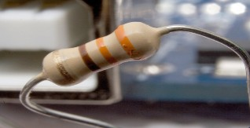
Color Coding
A process called color coding is used to determine the value of resistance for a resistor, just as shown in the above figure. A resistor is coated with four color bands where each color determines a particular value. The below table shows a list of values which each color indicates.

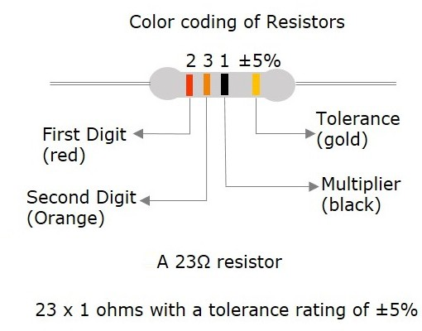
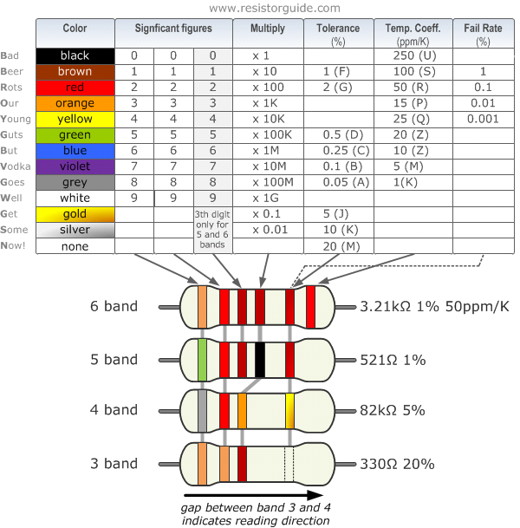
The first two colored bands indicate the first and second digit of the value and the third color band represents the multiplier (number of zeroes added). The fourth color band indicates the tolerance value.
Tolerance is the range of value up to which a resistor can withstand without getting destroyed. This is an important factor. The following figure shows how the value of a resistor is determined by color code.
The five color band resistors are manufactured with tolerance of 2% and 1% and also for other high accuracy resistors. In these five band resistors, the first three bands represent digits; fourth one indicates multiplier and the fifth represents tolerance.
Let us look at an example to understand the color coding process.
Example1 −Determine the value of a resistor with a color code yellow, blue, orange and silver. Solution − the value of yellow is 4, blue is 6, orange is 3 which represents multiplier. Silver is ±10 which is the tolerance value.
Hence the value of the resistor is 46 × 103 = 46kΩ
The maximum resistance value for this resistor is
46kΩ or 46000Ω +10%= 46000 + 4600= 50600Ω = 50.6 kΩ
The minimum resistance value for this resistor is
46kΩ or 46000Ω-10% = 46000-4600 = 41400Ω = 41.4kΩ
After having gone through different details regarding resistors we have some terms to learn. Also we have to deal with different behaviors of a resistor for few types of connections. A resistor when connected in a circuit, that connection can be either series or parallel. Let us now know what will happen to the total current, voltage and resistance value if they are connected in series as well, when connected in parallel.
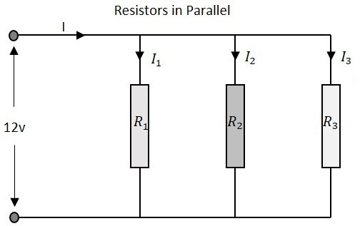
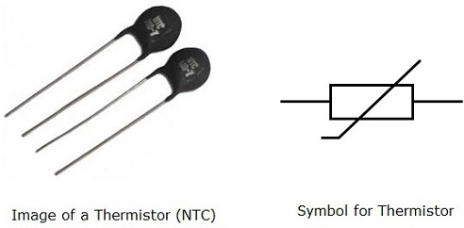
Resistors in Series
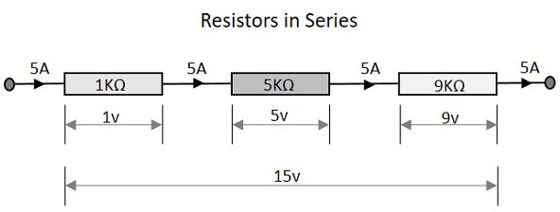
Let us observe what happens, when few resistors are connected in Series. Let us consider three resistors with different values, as shown in the figure below.

Resistance
The total resistance of a circuit having series resistors is equal to the sum of the individual resistances. That means, in the above figure there are three resistors having the values 1KΩ, 5KΩ and 9KΩ respectively.
Total resistance value of the resistor network is −

R=R1+R2+R3

Which means 1 + 5 + 9 = 15KΩ is the total resistance.

Where R1 is the resistance of 1stresistor, R2 is the resistance of 2ndresistor and R3 is the resistance of 3rdresistor in the above resistor network.

Resistors in Parallel
Let us observe what happens, when few resistors are connected in Parallel. Let us consider three resistors with different values, as shown in the figure below.
Resistance
The total resistance of a circuit having Parallel resistors is calculated differently from the series resistor network method. Here, the reciprocal (1/R) values of individual resistances are added with the inverse of algebraic sum to get the total resistance value.
Total resistance value of the resistor network is − 1/R=1/R1+1/R2+1/R3 Where R1 is the resistance of 1stresistor, R2 is the resistance of 2ndresistor and R3 is the resistance of 3rdresistor in the above resistor network.
For example, if the resistance values of previous example are considered, which means R1 = 1KΩ, R2 = 5KΩ and R3 = 9KΩ. The total resistance of parallel resistor network will be −
1/R=1/1000 + 1/5000 + 1/9000
From the method we have for calculating parallel resistance, we can derive a simple equation for to -resistor parallel network. (Product / sum)
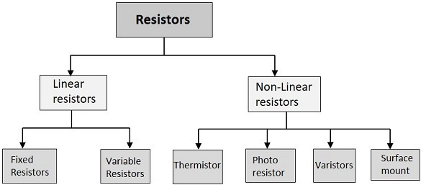
Rt =R1×R2R1+R2
Linear resistors have linear VI characteristics and non-linear resistors have non-linear VI characteristics. Non-linear resistors are the resistors whose voltage and current characteristics vary non-linearly. The voltage and current values vary depending upon other factors like temperature and light, but they may not be linear

Thermistor
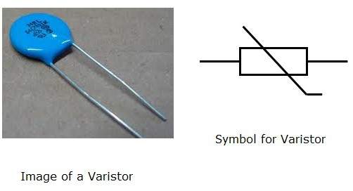
Thermal means temperature. In this resistor, the resistance varies with temperature. If heat increases, the resistance decreases and vice versa. This is used for measurement and control purposes.

Photo Resistor
Photo means light. In this resistor, the resistance varies with light. As light increases resistance decreases and vice versa. This is also used for measurement and control purposes. It is also called as LDR (Light Dependent Resistor)

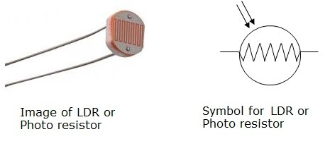

Varistors
The resistance of a varistor varies with the applied voltage. As the voltage increases, the resistance decreases and if the voltage decreases, the resistance increases. It is also called as VDR (Voltage Dependent Resistor).
Surface Mount
These are being highly used since the introduction of surface mount technology. These can be termed as chip resistors, which means a resistive layer integrated on a ceramic chip.
These surface mount resistors are very small when compared to the normal resistors and hence occupy less space. They are effective and dissipate less heat. The invention of these resistors has changed the look of a PCB (Printed Circuit Board) and reduced its size greatly.

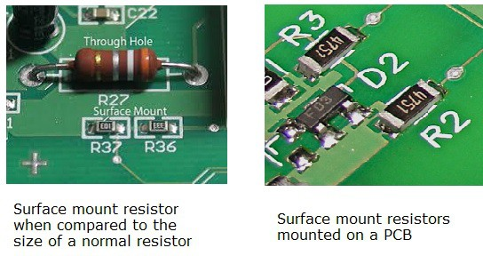

Variable Resistors
Variable resistors are those whose values can be varied manually, according to the requirement. A particular value of resistance is chosen from a range of resistance values; with the help of a shaft connected .The symbol of a variable resistor is as shown below.
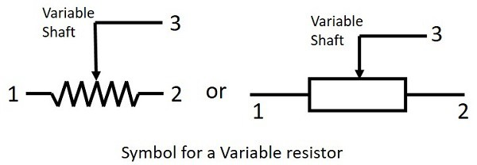

Fixed resistors
A resistor is said to be a fixed resistor, it its value is fixed .The value of fixed resistor can’t be varied like a variable resistor as it’s a determined at the time of manufacturing itself. The following figures represent the symbol of a fixed resistor.
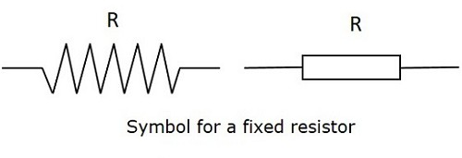
The fixed resistors are classified into different types, depending upon their manufacturing processes and the materials used in their manufacturing.

1.3 DIODE
After having known about various components, let us focus on another important component in the field of electronics, known as a Diode. A semiconductor diode is a two terminal electronic component with a PN junction. This is also called as a Rectifier.
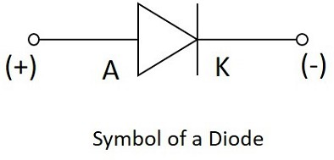

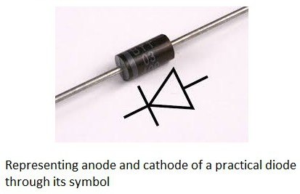
The anode which is the positive terminal of a diode is represented with A and the cathode, which is the negative terminal, is represented with K. To know the anode and cathode of a practical diode, a fine line is drawn on the diode which means cathode, while the other end represents anode.
As we had already discussed about the P-type and N-type semi conductors and the behavior of their carriers, let us now try to join these materials together to see what happens.

Formation of a Diode
If a P-type and an N-type material are brought close to each other, both of them join to form a junction, as shown in the figure below.
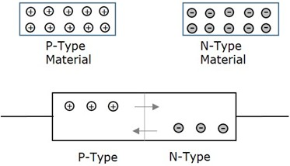
A P-type material has holes as the majority carriers and an N-type material has electrons as the majority carriers As opposite charges attract, few holes in P-type tend to go to N-side, where as few electrons in N-type tend to go to P-side. As both of them travel towards the junction, holes and electrons recombine with each other to neutralize and forms ions. Now, in this junction, there exists a region where the positive and negative ions are formed, called as PN junction or junction barrier as shown in the figure.
The formation of negative ions on P-side and positive ions on N-side results in the formation of a narrow charged region on either side of the PN junction. This region is now free from movable charge carriers. The ions present here have been stationary and maintain a region of space between them without any charge carriers.
As this region acts as a barrier between P and N type materials, this is also called as Barrier junction. This has another name called as Depletion region meaning it depletes both the regions. These occurs a potential difference VD due to the formation of ions, across the junction called as potential Barrier as it prevents further movement of holes and electrons through the junction Biasing of a Diode. When a diode or any two-terminal component is connected in a circuit, it has two biased conditions with the given supply. They are Forward biased condition and Reverse biased condition. Let us know them in detail.

Forward Biased Condition
When a diode is connected in a circuit, with its anode to the positive terminal and cathode to the negative terminal of the supply, then such a connection is said to be forward biased condition. This kind of connection makes the circuit more and more forward biased and helps in more conduction. A diode conducts well in forward biased condition.

Reverse Biased Condition
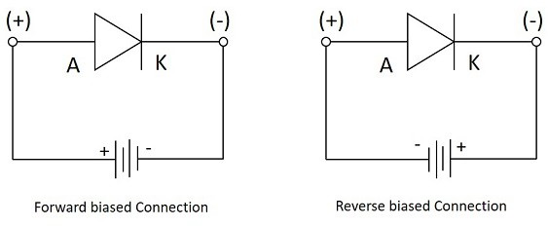
When a diode is connected in a circuit, with its anode to the negative terminal and cathode to the positive terminal of the supply, then such a connection is said to be Reverse biased condition. This kind of connection makes the circuit more and more reverse biased and helps in minimizing and preventing the conduction. A diode cannot conduct in reverse biased condition.
Let us now try to know what happens if a diode is connected in forward biased and in reverse biased conditions.

Working under Forward Biased
When an external voltage is applied to a diode such that it cancels the potential barrier and permits the flow of current is called as forward bias. When anode and cathode are connected to positive and negative terminals respectively, the holes in P-type and electrons in N-type tend to move across the junction, breaking the barrier. There exists a free flow of current with this, almost eliminating the barrier.
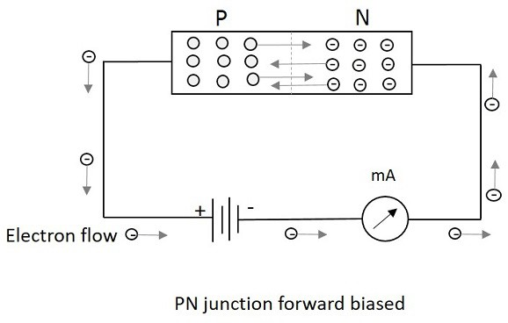

With the repulsive force provided by positive terminal to holes and by negative terminal to electrons, the recombination takes place in the junction. The supply voltage should be such high that it forces the movement of electrons and holes through the barrier and to cross it to provide forward current.
Forward Current is the current produced by the diode when operating in forward biased condition and it is indicated by If.

Working under Reverse Biased
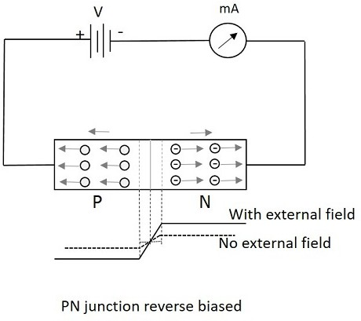
When an external voltage is applied to a diode such that it increases the potential barrier and restricts the flow of current is called as Reverse bias. When anode and cathode are connected to negative and positive terminals respectively, the electrons are attracted towards the positive terminal and holes are attracted towards the negative terminal. Hence both will be away from the potential barrier increasing the junction resistance and preventing any electron to cross the junction.
The following figure explains this. The graph of conduction when no field is applied and when some external field is applied are also drawn.
With the increasing reverse bias, the junction has few minority carriers to cross the junction. This current is normally negligible. This reverse current is almost constant when the temperature is constant. But when this reverse voltage increases further, then a point called reverse break down occurs, where an avalanche of current flows through the junction. This high reverse current damages the device.
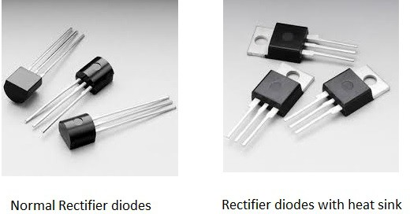

In the above figure, we can see the same rectifier diodes with a metal projection. This is added to the diode to minimize the heat distribution which might affect the diode sometimes .Such a metal projection is called as Heat sink. These help in the improvement of the diode performance and the diodes will be able to with stand high powers, without getting affected.
There are circuits such as Halfwave rectifier and Fullwave rectifier circuits which use these diodes. These circuits are discussed in ELECTRONIC CIRCUITS tutorial. These rectifier circuits are used in Power supply sections of many circuits where alternating input current has to be converted into direct current for that circuit application.

TYPES OFDIODE

LED (Light Emitting Diodes)

This one is the most popular diodes used in our daily life. This is also a normal PN junction diode except that instead of silicon and germanium, the materials like gallium arsenide, gallium arsenide phosphore are used in its construction. The figure below shows the symbol of a Light emitting diode.
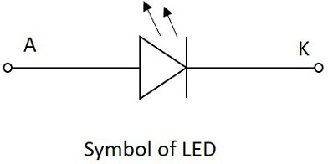
Like a normal PN junction diode, this is connected in forward bias condition so that the diode conducts. The conduction takes place in a LED when the free electrons in the conduction band combine with the holes in the valence band. This process of recombination emits light. This process is called as Electroluminescence. The color of the light emitted depends upon the gap between the energy bands.
The materials used also affect the colors like, gallium arsenide phosphide emits either red or yellow, gallium phosphide emits either red or green and gallium nitrate emits blue light. Whereas gallium arsenide emits infrared light. The LEDs for non-visible Infrared light are used mostly in remote controls.
The following figure shows a how the practical LEDs of different colors looks like.
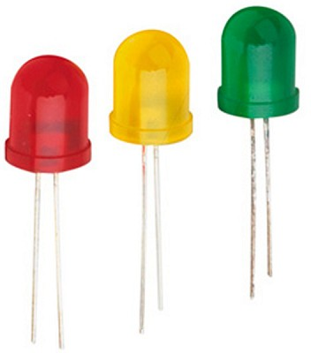
LED in the above figure has a flat side and curved side, the lead at the flat side is made shorter than the other one, so as to indicate that the shorter one is Cathode or negative terminal and the other one is Anode or the positive terminal.

The basic structure of LED is as shown in the figure below.
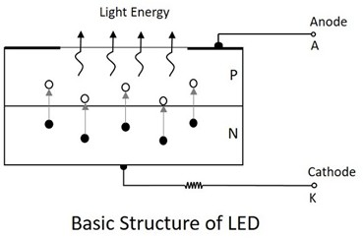

As shown in the above figure, as the electrons jump into the holes, the energy is dissipated spontaneously in the form of light. LED is a current dependent device. The output light intensity depends upon the current through the diode.

Advantages of LED
There are many advantages of LED such as −
- High efficiency
- High speed
- High reliability
- Low heat dissipation
- Larger lifespan
- Low cost
- Easily controlled and programmable
- High levels of brightness and intensity
- Low voltage and current requirements
- Less wiring required
- Low maintenance cost
- No UV radiation
- Instant Lighting effect

Applications of LED

There are many applications for LED such as;
In Displays
- Especially used for seven segment display
- Digital clocks
- Microwave ovens
- Traffic signaling
- Display boards in railways and public places

In Electronic Appliances
- Stereo tuners
- Calculators
- DC power supplies
- On/Off indicators in amplifiers
- Power indicators
Commercial Use
- Infrared readable machines
- Barcode readers
- Solid state video displays
Optical Communications
In Optical switching applications
- for optical coupling where manual help is unavailable
- Information transfer through FOC
- Image sensing circuits
- Burglar alarms
- In Railway signaling techniques
- Door and other security control systems
Just as LED has many advantages and applications, there is another important diode called Laser diode, which also has got many advanced features and scope of future. Let us discuss about Laser diode.

1.4 TRANSISTOR

A Transistor is a three terminal semiconductor device that regulates
Current or voltage flow and acts as a switch or gate for signals.

Why Do We Need Transistors?
Suppose that you have a FM receiver which grabs the signal you want. The received signal will obviously be weak due to the disturbances it would face during its journey. Now if this signal is read as it is, you cannot get a fair output. Hence we need to amplify the signal. Amplification means increasing the signal strength.
This is just an instance. Amplification is needed wherever the signal strength has to be increased. This is done by a transistor. A transistor also acts as a switch to choose between available options. It also regulates the incoming current and voltage of the signals.

Constructional details of a Transistor
Transistor is a three terminal solid state device which is formed by connecting two diodes back to back. Hence it has got two PN junctions. Three terminals are drawn out of the three semiconductor materials present in it. This type of connection offers two types of transistors. they are PNP and NPN which means an N-type material between two P types and the other is a P-type material between two N-types respectively.
The construction of transistors is as shown in the following figure which explains the idea discussed above.
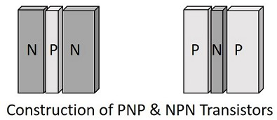

The three terminals drawn from the transistor indicate Emitter, Base and Collector terminals. They have their functionality as discussed below.

Emitter
- The left hand side of the above shown structure can be understood as Emitter.
- This has a moderate size and is heavily doped as its main function is to supply a number of majority carriers, i.e. either electrons or holes.
- As this emits electrons, it is called as an emitter.
- This is simply indicated with the letter E.
Base
- The middle material in the above figure is the Base.
- This is thin and lightly doped.
- Its main function is to pass the majority carriers from the emitter to the same collector.

. Collector

- The right side material in the above figure can be understood as a Collector.
- Its name implies its function of collecting the carriers.
- This is a bit larger in size than emitter and base. It is moderately doped.
- This is indicated by the letter C.

The symbols of PNP and NPN transistors are as shown below.
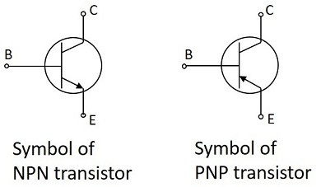
The arrow-head in the above figures indicated the emitter of a transistor and. As the collector of a transistor has to dissipate much greater power, it is made large. Due to the specific functions of emitter and collector, they are not interchangeable. Hence the terminals are always to be kept in mind while using a transistor.
In a Practical transistor, there is a notch present near the emitter lead for identification. The PNP and NPN transistors can be differentiated using a multimeter.The following figure shows how different practical transistors look like.
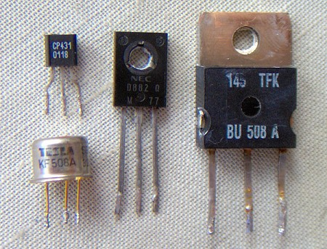

We have so far discussed the constructional details of a transistor, but to understand the operation of a transistor, first we need to know about the biasing.

Transistor Biasing

As we know that a transistor is a combination of two diodes, we have two junctions here. As one junction is between the emitter and base, that is called as Emitter-Base junction and likewise, the other is Collector-Base junction.
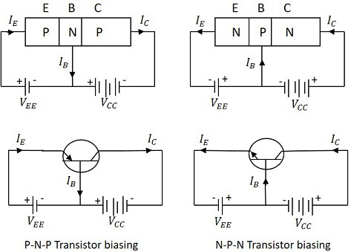
Biasing is controlling the operation of the circuit by providing power supply. The function of both then junctions is controlled by providing bias to the circuit through some DC supply. The figure below shows how a transistor is biased.
By having a look at the above figure, it is understood that
- The N-type material is provided negative supply and P-type material is given positive supply to make the circuit Forward bias.
- The N-type material is provided positive supply and P-type material is given negative supply to make the circuit Reverse bias.
By applying the power, the emitter base junction is always forward biased as the emitter resistance is very small. The collector base junction is reverse biased and its resistance is a bit higher. A small forward bias is sufficient at the emitter junction where as a high reverse bias has to be applied at the collector junction.
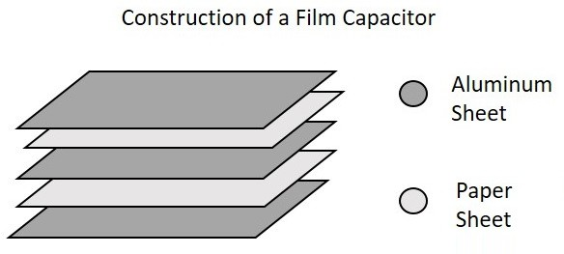
The direction of current indicated in the circuits above, also called as the Conventional Current, is the movement of hole current which is opposite to the electron current.

Operation PNP Transistor

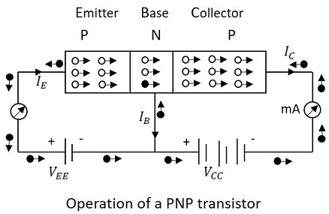
The operation of a PNP transistor can be explained by having a look at the following figure, in which emitter-base junction is forward biased and collector-base junction is reverse biased.
The voltage VEE provides a negative potential at the emitter which repels the electrons in the N- type material and these electrons cross the emitter-base junction, to reach the base region. There a very low percent of electrons recombine with free holes of P-region. This provides very low current which constitutes the base current IB. The remaining holes cross the collector-base junction, to constitute the collector current IC.
As an electron reaches out of the collector terminal, and enters the positive terminal of the battery, an electron from the negative terminal of the battery VEE enters the emitter region. This flow slowly increases and the electron current flows through the transistor. Hence we can understand that −

- The conduction in a NPN transistor takes place through electrons.
- The collector current is higher than the emitter current.
- The increase or decrease in the emitter current affects the collector current.

Advantages

There are many advantages of a transistor such as −
- High voltage gain.
- Lower supply voltage is sufficient.
- Most suitable for low power applications.
- Smaller and lighter in weight.
- Mechanically stronger than vacuum tubes.
- No external heating required like vacuum tubes.
- Very suitable to integrate with resistors and diodes to produce ICs.

There are few disadvantages such as they cannot be used for high power applications due to lower power dissipation. They have lower input impedance and they are temperature dependent.

A Transistor has 3 terminals, the emitter, the base and the collector. Using these 3 terminals the transistor can be connected in a circuit with one terminal common to both input and output in a 3 different possible configurations.
The three types of configurations are Common Base, Common Emitter and Common Collector configurations. In every configuration, the emitter junction is forward biased and the collector junction is reverse biased.

Common Base (CB) Configuration

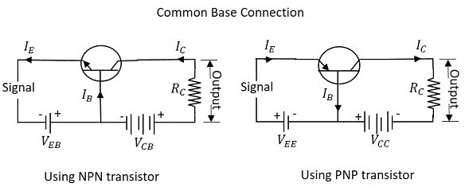
As the name implies that the Base terminal is taken as common terminal for both input and output of the transistor. The common base connection for both NPN and PNP transistors is as shown in the following figure.
For the sake of understanding, let us consider NPN transistor in C B configuration. When the emitter voltage is applied, as it is forward biased, the electrons from the negative terminal repel the emitter electrons and current flows through the emitter and base to the collector to contribute collector current. The collector voltage VCB is kept constant throughout this.
In the CB configuration, the input current is the emitter current IE and the output current is the collector current IC.

Common Emitter (CE) Configuration

The name itself implies that the Emitter terminal is taken as common terminal for both input and output of the transistor. The common emitter connection for both NPN and PNP transistors is as shown in the following figure.
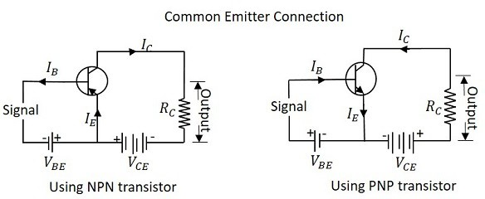
Just a sin CB configuration, the emitter junction is forward biased and the collector junction is reverse biased. The flow of electrons is controlled in the same manner. The input current is the Knee Voltage.
Knee Voltage
In CE configuration, by keeping the base current IB constant, if VCE is varied, IC increases nearly to 1v of VCE and stays constant thereafter. This value of VCE up to which collector current IC changes with VCE is called the Knee Voltage. The transistors while operating in CE configuration, they are operated above this knee voltage.

Characteristics of CE Configuration

- This configuration provides good current gain and voltage gain.
- Keeping VCE constant, with a small increase in VBE the base current IB increases rapidly than in CB configurations.
- For any value of VCE above knee voltage, IC is approximately equal to βIB.
- The input resistance r is the ratio of change in base emitter voltage (ΔVBE) to the change in base current (ΔIB) at constant collector emitter voltage VCE.
R =ΔVBEΔIB at constant VCE
- As the input resistance is of very low value, a small value of VBE is enough to produce a large current flow of base current IB.
- The output resistance ro is the ratio of change in collector emitter voltage (ΔVCE) to the change in collector current (ΔIC) at constant IB.
ro=ΔVCEΔ IC at constant IB
- As the output resistance of CE circuit is less than that of CB circuit.
- This configuration is usually used for bias stabilization methods and audio frequency applications.

Common Collector (CC) Configuration

The name itself implies that the Collector terminal is taken as common terminal for both input and output of the transistor. The common collector connection for both NPN and PNP transistors is as shown in the following figure.
Just as in CB and CE configurations, the emitter junction is forward biased and the collector junction is reverse biased. The flow of electrons is controlled in the same manner. The input current is the base current IB and the output current is the emitter current IE here.

Current Amplification Factor (γ)

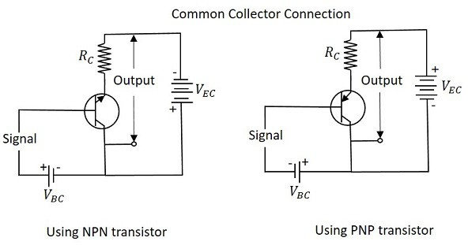
The ratio of change in emitter current (ΔIE) to the change in base current (ΔIB) is known as Current Amplification factor in common collector (CC) configuration. It is denoted by γ.

γ=ΔIEΔIB

- The current gain in CC configuration is same as in CE configuration.
- ThevoltagegaininCCconfigurationisalwayslessthan1.

Characteristics of CC Configuration

- This configuration provides current gain but no voltage gain.
- In CC configuration, the input resistance is high and the output resistance is low.
- The voltage gain provided by this circuit is less than 1.
- The sum of collector current and base current equals emitter current.
- The input and output signals are in phase.
- This configuration works as non-inverting amplifier output.
- This circuit is mostly used for impedance matching. That means, to drive a low impedance load from a high impedance source.
- The DC supply is provided for the operation of a transistor. This DC supply is given to the two PN junctions of a transistor which influences the actions of majority carriers in these emitter and collector junctions.
- The junctions are forward biased and reverse biased based on our requirement. Forward biased is the condition where a positive voltage is applied to the p-type and negative voltage is applied to the n-type material. Reverse biased is the condition where a positive voltage is applied to the n-type and negative voltage is applied to the p-type material.

Transistor biasing

The supply of suitable external DC voltage is called as either forward or reverse or reverse biasing is done to the emitter and collector junctions of the transistor. These biasing methods make the transistor circuit to work in four kinds of regions such as Active region, Saturation region, Cutoff region and Inverse active region (seldom used). This is understood by having a look at the follow in.

EMITTER JUNCTION COLLECTOR JUNCTION REGION OF OPERATION

Forward biased F o r w a r d b i a s ed Saturation region Forward biased R e v e r s e. b i a s ed A c t i v e r e g i o n Reverse biased F o r w a r d b i a s ed Inverse active region Reverse biased R e v e r s e b i a s ed Cutoff region

Among these regions, Inverse active region, which is just the inverse of active region, is not suitable for any applications and hence not used.

Active region
This is the region in which transistors have many applications. This is also called as linear region transistor while in this region, acts better as an amplifier.
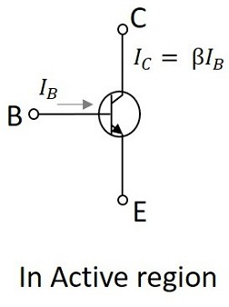

This region lies between saturation and cutoff. The transistor operates in active region when the emitter junction is forward biased and collector junction is reverse based. In the active state, collector current is β times the base current, i.e.,

IC=βIB

Where,
IC = collector current
β = current amplification factor
IB = base current

Saturation region
This is the region in which transistor tends to behave as a closed switch. The transistor has the effect of its collector and Emitter being shorted. The collector and emitter currents are maximum in this mode of operation. The figure below shows a transistor working in saturation region.
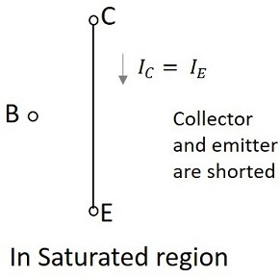
The transistor operates in saturation region when both the emitter and collector junctions are forward biased. As it is understood that, in the saturation region the transistor tends to behave as a closed switch, we can say that, IC=IE
Where
IC=collector current
IE=emitter current.

Cutoff region
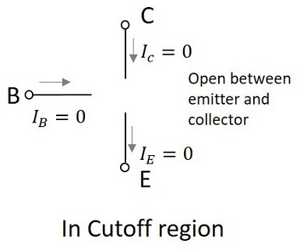
This is the region in which transistor tends to behave as an open switch. The transistor has the effect of its collector and base being opened. The collector, emitter and base currents are all zero in this mode of operation. The following figure shows a transistor working in cutoff region.

The transistor operates in cutoff region when both the emitter and collector junctions are reverse biased. As in cutoff region, the collector current, emitter current and base currents are nil, we can write it as
IC=IE=IB=0
Where
IC=collector current,
IE=emitter current
IB=base current.
Till now we have discussed different regions of operation for a transistor .But among all these regions, we have found that the transistor operates well inactive region and hence it is also called as linear region. The outputs of the transistor are the collector current and collector voltages.

Bipolar Junction Transistor

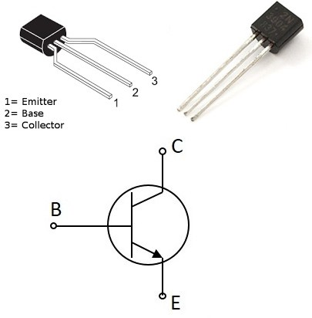
A Bipolar junction transistor, shortly termed as BJT is called so as it has two PN junctions for its function. This BJT is nothing but a normal transistor. It has got two types of configurations NPN and PNP. Usually NPN transistor is preferred for the sake of convenience. The following image shows how a practical BJT looks like.
The types of BJT are NPN and PNP transistors. The NPN transistor is made by placing a p type material between to n-type materials. The PNP transistor is made by placing an n-type material between two p-type materials.

BJT is a current controlled device. A normal transistor which we had discussed in the previous chapters comes under this category. The functionality, configurations and applications are all the same.

Field Effect Transistor
An FET is a three-terminal unipolar semiconductor device. It is a voltage controlled device unlike a bipolar junction transistor. The main advantage of FET is that it has very high input impedance, which is in the order of Mega Ohms. It has many advantages like low power consumption, low heat dissipation and FETs are highly efficient devices. The following image shows how a practical FET looks like.
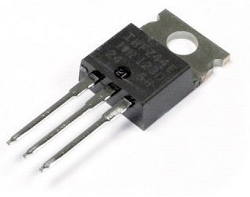
The FET is a unipolar device, which means that it is made using either p-type or n-type material as main substrate. Hence the current conduction of a FET is done by either electrons or holes.

Features of FET
The following are the varied features of a Field Effect Transistor.
- Unipolar−Itisunipolaraseitherholesorelectronsareresponsibleforconduction.
- Highinputimpedance−TheinputcurrentinaFETflowsduetothereversebias.Hence it has high input impedance.
- Voltagecontrolleddevice−AstheoutputvoltageofaFETiscontrolledbythegateinput voltage, FET is called as the voltage controlled device.
- Noiseislow−Therearenojunctionspresentintheconductionpath.Hencenoiseis lower than in BJTs.
- Gainischaracterizedastransconductance.Transconductanceistheratioofchangein output current to the change in input voltage.
- The output impedance of a FET is low.

Advantages of FET
To prefer a FET over BJT, there should be few advantages of using FETs, rather than BJTs. Let us try to summarize the advantages of FET over BJT.

Applications of FET
- FET is used in circuits to reduce the loading effect.
- FETs are used in many circuits such as Buffer Amplifier, Phase shift Oscillators and Voltmeters.
- panel.

1.7 VEROBOARD
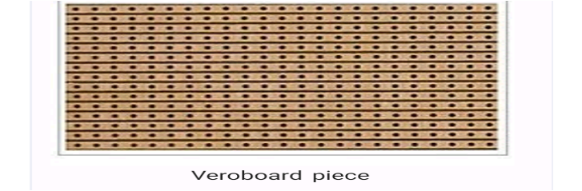
Vero board is a printed circuit board that’s designed with rows of copper tracks with holes drilled in then for electronic components to be soldered to construct electronic circuits. The hole and tracks are all spaced a tenth of an inch apart. If that dimension sounds familiar it’s because it’s the same spacing as IC’s Use so these will fit perfectly. The idea is that all the holes on a row are joined electrically by the copper strip so you plan your layout accordingly.
Sometimes you won’t want the continuous copper strip so you will have to cut it to break the circuit. This happens when you use an IC. You will have for break the tracks of all the joined pine under the IC.

1.8 Soldering iron
Soldering iron is an electrical tool used for melting solder and applying it to
Metals that are to be joined.
Soldering is a process in which two or more metal items are joined together by melting and then flowing a filler metal into the joint—the filler metal having a relatively low melting point.
- Soldering is used to form a permanent connection between electronic components.
- The metal to be soldered is heated with a soldering iron and then solder is melted in to the connection.
- Only the solder melts, not the parts that are being soldered.
- Solder is metallic glue that holds the parts together and forms a connection that allows electrical current to flow.

Equipment need for soldering
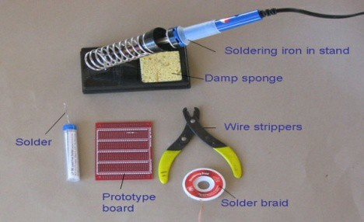

Soldering equipment and materials. The solder in this picture is coiled inside a plastic tube; it is pulled through the top as needed. The spring on the stand holds the hot soldering iron. The damp sponge is used to clean the tip of the iron. Solder braid is used to remove solder; solder is "soaked up" into the braid when it is heated by the soldering iron. The wire strippers can be adjusted to strip the plastic covering off of various thicknesses of wire. The prototype board is used to connect electronic components in a circuit.
Solder braid
- This is used to remove solder.
- Touse the braid, place it over the solder to be removed and heat it from above with the iron. The solder will flow into the braid.
- Solder braid is used to extract an electronic component that is soldered onto aboard.
- It is also used to reduce the amount of solder on a connection.
Prototype board
- A prototype board is used to assemble the circuit. The board shown is from www. proto stack. Com, but Jameco Electronics also supplies prototype boards.
- Prototype boards have copper tracks or pads for connecting components.
Steel wool or fine sand paper
- This is used to clean connections prior to soldering.
- Solder will not flow over a dirty connection.
Crocodile clips
- These can be used as heat sinks ,if needed.
Safety Precautions
- Caution: A soldering iron can heat to around 400°C, which can burn you or start a fire, souse it carefully.
- Unplug the iron when it is not in use.
- Keep the power cord away from spots where it can be tripped over.
- Take great Care to avoid touching the tip of the soldering iron on a power line. If a power cord is touched by a hot iron, there is a serious risk of burns and electric shock.
- Always return the soldering iron to its stand when it is not in use.
- Never put the soldering iron down on your work bench, even for a moment! Work in a well-ventilated area.
- The smoke that will form as you melt solder is mostly from the
Flux and can be quite irritating.
- Avoid breathing it by keeping your head to the side of, not above, your work.
- Solder contains lead, which is a poisonous metal. Wash your hands after using solder.

Tips

Reliable operation of a circuit with soldered connections depends on good soldering practices.Here are some tips for successful soldering.
- Plan before you start to solder. Identify all the parts that you will be using.
- It is helpful to attach each part to a piece of paper and write what it is and its value (for example, resistor #1: 100ohms).
- Some components, such as LED's, must be placed the correct way around in order to function.
- The following is a suggested order for the installation of various components:
Integrated circuit (IC) holders (note the orientation).The IC will be added later.

Preparing the Soldering Iron
- Place the soldering iron in its stand and plug it in.
- Wait for the soldering iron to heat up.
- Moisten the sponge.
- Wipe the tip of the iron on the damp sponge. This will clean the tip.
- Melt a little solder on the tip of the iron.

Soldering
- Solder needs a clean surface on which to adhere.
- Buff the copper foil of a PC board with steel wool before soldering.
- Remove any oil, paint, wax, etc. with a solvent, steel wool, or fine sandpaper.
- To solder, the connection with the tip of the soldering iron for a few seconds, then apply the solder.
- He at the connection, not the solder.
- Hold the soldering iron like a pen, near the base of the handle.
- Both parts that are being soldered have to be hot to for a good connection.
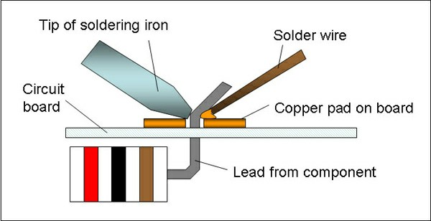
The tip of the soldering iron heats both the copper pad and the lead from the electronic component. Solder melts when placed in contact with the hot metals to be joined.
- Keep the soldering tip on the connection as the solder is applied.
- Solder will flow into and around well-heated connections.
- Use just enough solder to form a strong connection.
- Remove the tip from the connection as soon as the solder has flowed where you want it to be. Remove the solder, then the iron.
- Don't move the connection while the solder is cooling.
- Don't overheat the connection, as this might damage the electrical component you are soldering.
Transistors and some other components can be damaged by heat when soldering. A crocodile clip can be used as a heat sink to protect these components.
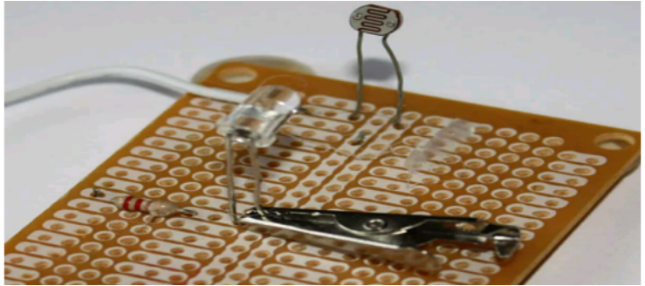
By absorbing heat, the crocodile clip will reduce the heat that flows to the component, helping to prevent damage.
- Soldering a connection should take just a few seconds.
If it is taking longer, see the troubleshooting section below.
- Inspect the joint closely. It should look shiny.
- If you are soldering a wire (called the lead) onto a PC board (on the track), it should have a volcano shape. See Figure
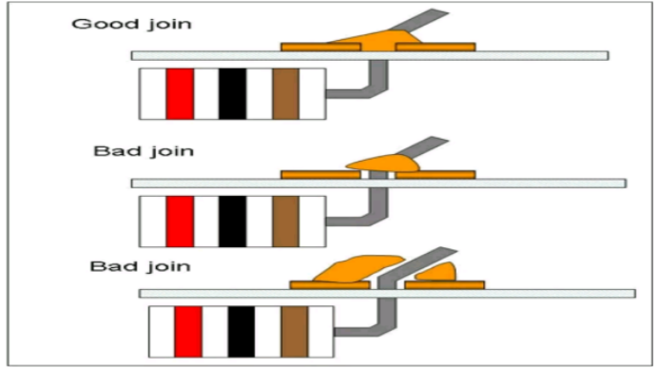
- If the connection looks bad, reheat it and try again.
The solder in a good join will be shaped like a cone, with solid contact between the solder and all surfaces to be joined. Bad joins (also called dry joins) should be melted and remade.
- Wipe the tip of the iron on a damp sponge to clean it. The tip should now be shiny.
- Unplug the soldering iron when it is not in use.

Common Problems and Troubleshooting

- Solder will not flow.
- The parts to be joined may be dirty. Remove the solder and clean the parts.
- The connection looks grainy or crystalline.
- Parts were moved before the solder was allowed to cool.
- Reheat to for a good joint. You may need a larger soldering iron to heat connections adequately.
- The tip is oxidized.
- Soldering is much easier with a shiny, clean tip.
- Clean the tip with a damp synthetic sponge while there on is hot.
- To avoid oxidizing the tip, do not leave the iron plugged in when not in use.
- Do not use the iron at a higher temperature than is necessary to melts older.
- Clean the tip of the iron on a damp synthetic sponge as soon as it starts to change from a silver color.
- There is too much or too little solder.
- Using too much solder can cause as older bridge, which means that two adjacent joints are accidentally connected.
- Using too little solder might result in poor electrical continuity between the board and component. The connection should be smooth,shiny,and rigid.

PCB (PRINTED CIRCUIT BOARD)-
A printed circuit board (PCB) mechanically supports and electrically connects electronic
components using conductive tracks, pads and other features etched from copper sheets laminated onto a non-conductive substrate. PCBs can be single sided (one copper layer), double sided (two copper layers) or multi-layer. Conductors on different layers are connected with plated-through holes called bias. Advanced PCBs may contain components - capacitors, resistors or active devices - embedded in the substrate.
POWER SUPPLY
A power supply is a device that supplies electric power to an electrical load. The term is most
commonly applied to electric power converters that convert one form of electrical energy to another, though it may also refer to devices that convert another form of energy (mechanical, chemical, solar) to electrical energy. A regulated power supply is one that controls the output voltage or current to a specific value; the controlled value is held nearly

CHAPTER TWO
DESIGN PROCEDURE

The automatic light control system operates on 12 V DC supply. The automatic light
controller has a photoconductive device whose resistance changes proportional to the extent
of illumination, which switches ON or OFF the LED with the use of transistor as a switch.
Light dependent resistor, a photoconductive device has been used as the transducer to convert light energy into electrical energy. The central dogma of the circuit is that the change in voltage drop across the light dependent
resistor on illumination or darkness switches the transistor between cut-off region or saturation
region and switches OFF or ON the LED as we know property of LDR that during the time of day resistance is low therefore voltage at the inverting input ( IE pin 2) is higher than the voltage at the non-inverting input (pin3) hence the output at the pin6 is low so the transistor goes into the cut off state which means LED or bulb will not glow.

CIRCUIT DIAGRAM
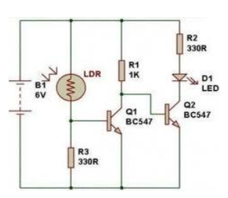

Figure – Circuit diagram of automatic light controller.
WORKING
Circuit of a compact and true solid-state automatic lawn light is described here.
The circuit can be used to switch on incandescent garden light bulbs at desk and switch off them at dawn. A 10 mm encapsulated light dependent resistor (LDR) here works as the twilight detector. The whole circuit can be housed in a very small plastic cabinet.
For powering the circuit AC household supply is needed. With a little skill and patience, you can
easily modify this circuit to drive a number of white LED strings, instead of the incandescent bulb load at the output. When ambient light is normal, transistor T1 is reverse biased by the low resistance of LDR. Multi turn plastic trimpotP1 sets the detection sensitivity. If ambient light dims, transistor T1 turns on to drive the triac T2. Now the lamp load at the output of T2 energizes. When the ambient light level restores, circuit returns to its idle state and light(s) switched off by the circuit. Working voltage for the circuit is derived directly from the AC supply input through components R1, R2 and R3. This obviates the requirement of a bulky.
If you wish to operate the, light bulb(s) on a little reduced power, just replace the triac T2 with a
suitable silicon controlled rectifier (SCR). This may give a long life to the incandescent load. Finally, the LDR should not be mounted to receive direct sunlight. It may be mounted at the top of the enclosure, pointing to the sky say southwards.
LDR offers Very high Resistance in darkness. In this case the voltage drop across the LDR is more than 0.7V.This voltage is more sufficient to drive the transistor into saturation region. In saturation region, IC (Collector current) is very high. Because of this IC. The relay gets energized, and switches on the lamp. LDR offers Very low Resistance in brightness. In this case the voltage drop across the LDR is less than 0.7V. This voltage is not sufficient to drive the transistor into saturation region. Hence, the transistor will be in cut-off region. In cut-off region, IC (Collector current) is zero. Because of this IC, The relay will not be energized, and the lamp will be in ON state only. Diode is connected across the relay to neutralize the reverse EMF generated.

LIST OF COMPONENTS

S.NO. | PARTS | RANGE | QUANTITY
1. | LDR | 1
2. | TRANSISTOR | BC -547 NPN | 2
3. | RESISTOR | 1K, 330 ohm | 3
4. | LED | 1
5. | PCB | 1
6. | POWER SUPPLY | 6V OR 9V | 1

CHAPTER THREE
CONSTRUCTION DETAILS
Basically this chapter contains the details of mounting of components together on the Vero board so as to produce what is known as ' Automatic Light Controller'.
PROCEDURE
1. Insert first transistor Q1-SL100 (NPN) on PCB board shown in the circuit diagram
2. Connect Resistor R1 1KΏ from base terminal of a transissor on PCB board shown in the circuit diagram.
3. Connect wires across emitter pin of both transistor and negative terminal of battery on the
PCB board.
4. Connect a wire across collector pin of transistor Q1 and base pin of transistor Q2.
5. Connect a resistor 1k across positive terminal of battery on the PCB board and collector pin
transistor Q1.
6. Connect LDR (Light Dependent Resistor) across positive terminal of the battery and base
terminal of transistor Q1
7. Insert a transistor 330 ohm across base pin of transistor Q1 and negative terminal of battery.
8. Connect a resistor 330 ohm across positive terminal of battery and anode terminal of LED
connect the cathode terminal of LED to collector pin of transistor Q2.
7. ADVANTAGES & DISADVANTAGES
By using this automatic system for light controller ,we can reduce energy consumption
because the manually operated lights are not switch off properly even the sun light comes and Also not switched on earlier before sunset
• Low cost
• Automated operation
• Low power consumption
• Very flexible
• Easy to manufactured
In sunny and rainy days, on and off time differ notice which is one of the major disadvantages of
using timer circuit or manual operation for switching the street light system.
- Meter Test
- Bread Board Test
- Circuit Diagram
4. Assembling of Components
5. Case construction
3.1 METER TEST
In this project, I decided to use digital multi-meter tester to each component where I obtained the actual value of each component.
3.2 BREAD BOARD TEST
After testing the components with the meter (Digital Multi-Meter Tester), it was then transferred to the bread board which does not involve soldering of components. It is very important because when the component gets burnt it can easily be change, or when the component is faulty. It is also important especially in the sub-system, such as the power, oscillator, tone generator, etc. it is easily rectified when it fells to operate or function than when wanted directly on the new board (Vero board) which involves soldering of components.
3.3 CIRCUIT DIAGRAM
Circuit diagram is necessary to be considered from the entire part of the chapter three because it provides a broad and a comprehensive knowledge an also background of the whole project. And it gives detail on the components and their rating before encasement. See the figure bellow:
3.4 ASSEMBLING OF COMPONENTS
This stage involves mounting of components such as Resistors, Diode, Capacitors, Transistor, Integrated Circuit and Light Emitting Diode Etc. on a Vero board for permanent and final connection. When mounting the components, proper care must be taken to ensure that it is mounted in accordance to the circuit diagram. The components are usually mounted by soldering.
3.5 SOLDERING
Soldering is defined as the joining of light articles by fusion of alloys which have relatively low melting point. Some components does not require much heat, care must always be taken in order not to burn the components. The materials used in mounting of the components are: Soldering iron, solder (Tin lead alloy) liquor thinner, Brush and Vero board. The greatest danger during soldering is overheating and if the IC exposed to high temperature for a long period it may be damaged. It is also important to use suitable fluxes to avoid deterioration of the leads.

3.6 CASE CONSTRUCTION
The casing is what houses the entire assembled components in one place. The following materials are largely considered suitable for case construction. These include:
1. Plastic
2. Scriber
3. Steel rule
4. Saw
5. Screw
6. Nails
7. Hammer
The steel rule and scriber are used for taking measurement and marking out lines respectively, drilling machine I also used for drilling holes. Nails were used to tighten the parts together.
3.7 PROBLEM AND SOLUTION
The problem encountered during this project is insufficient skills in handling of soldering iron due to the lack of routine practice and the skills of applying heat to the components, sometimes heat may be little or higher than is required, as a result of that, some of the components got burnt which caused more time consumption on the soldering.

3.8 SOLUTION
It is believed that experience is the best teacher, this has really manifested in me through consistence practice of the project. I became a little bit skillful in Soldering and mounting components, and the burnt components were re-purchased. Advisably, it is good to focus and be conscious enough when Soldering so as to avoid getting the components burnt.

CHAPTER FOUR
TESTING AND EVALUATION
Testing components is normally carried out by the use of measuring instrument in order to obtain a desired and satisfactory functioning of project construction. This helps to discover the occurrence of fault so as to avoid damage to components. When circuits are designed, it is important to carry out test on breadboard before mounting them permanently on the Vero board. In the case of the construction of this solar powered alarm with feedback, all the components used were tested and found to be normal before being mounted on the Vero board. However, some of the tests that were carried out on some components are described below;
4.1 RESISTOR TEST
Resistor, when tested with a meter set at ohm, the pointer / niddle deflects to a reading corresponding to the value of the resistor. This is crosschecked with the color code on the resistor.
4.2 DIODE TEST
The testing of diode could be made by the use of ohm meter. To test diode in reversed bias direction, connect the diode across the ohm meter lead set range, switch on a light resistance such as 1kv, 10kv or even mega ohm.
OBSERVATION: The diode shows a high resistance.
4.3 CAPACITOR TEST
The test of the capacitor could be made with ohm meter. With the power disconnected, connect the terminals of the ohm meter across the capacitor terminals.
OBSERVATION: The needle swings up scale and return to infinity; the needle moved twice as for upscale and return to the infinity setting.
Precaution:
This is one of the most essential measure that can be greatly enhance the efficiency of the trouble free performance of any appliance and it will help in sustaining the life span of any device for a longer time as it is due some of the precaution to be observed when testing includes:
    - Do not apply over current or excess current demand for the circuit.
    - When soldering of component, do not apply excess heat on the component.
4.4 Encasement Test:
After encasement, the system was tested and was functioning as designed. Finally, the “Automatic Light Controller” was tested in the workshop under or through the supervision of my able supervisor and was approved.

CHAPTER FIVE
CONCLUSION
This chapter involves general comments on the result of tests (from above), the limitation, disappointment and hints to enhance further improvement on the design. In this chapter, we discussed how various testing were carried out which is the only means of evaluation and standard means of judgment, which it proved to give positive outcomes. The researchers have succeeded and achieved the desired goal by constructing the project. The construction of this project gives an avenue for gaining a remarkable knowledge and practical skills.
The Automatic light controller using LDR based Light intensity & traffic density, in the today’s up growing countries will be more effective in case of cost, manpower and security as compare with today's running complicated and complex light controlling systems. Automatic Light Controlling System puts up a very user friendly approach and could increase the power
this paper elaborate the design and construction of automatic light control system circuit. Circuit works properly to turn lamp ON/OFF. After designing the circuit which controls the light of the lamp / bulb as illustrated in the previous sections. LDR sensor and the photoelectric sensors are the two main conditions in working the circuit. If the two conditions have been satisfied the circuit will do the desired work according to specific program. Each sensor controls the turning ON or OFF the lighting column. Furthermore the drawback of the light system using timer controller has been overcome, where the system depends on photoelectric sensor.

LIMITATION
With regard to this project, the maximum power supply voltage for the circuit to perform effectively is 12 volts. Any voltage beyond this may cause damage to the circuit, and voltage below this may cause the system not to operate normally. During the installation, problem encountered were burning of some components during testing and also other component are difficult to found in the market but at the end it was over come.

RECOMMENDATION
This project is intended to give information to electrical and electronics students for further reference. It can also be useful to electrical and electronics students and technicians in the industry. It will serve as a steppingstone to the acquisition of practical skills and procedure. This project will serve as a guide for students who want to learn minimum theory necessary to be allowed in the successful implementation of the project. This project is introduced for further study and improvement in the field.
FUTURE SCOPE
We can save the energy for the future use and we can control the losses of the power
. We can implemented this project for the home lamp or night lamp of the room. This
is also used for the signals.

